
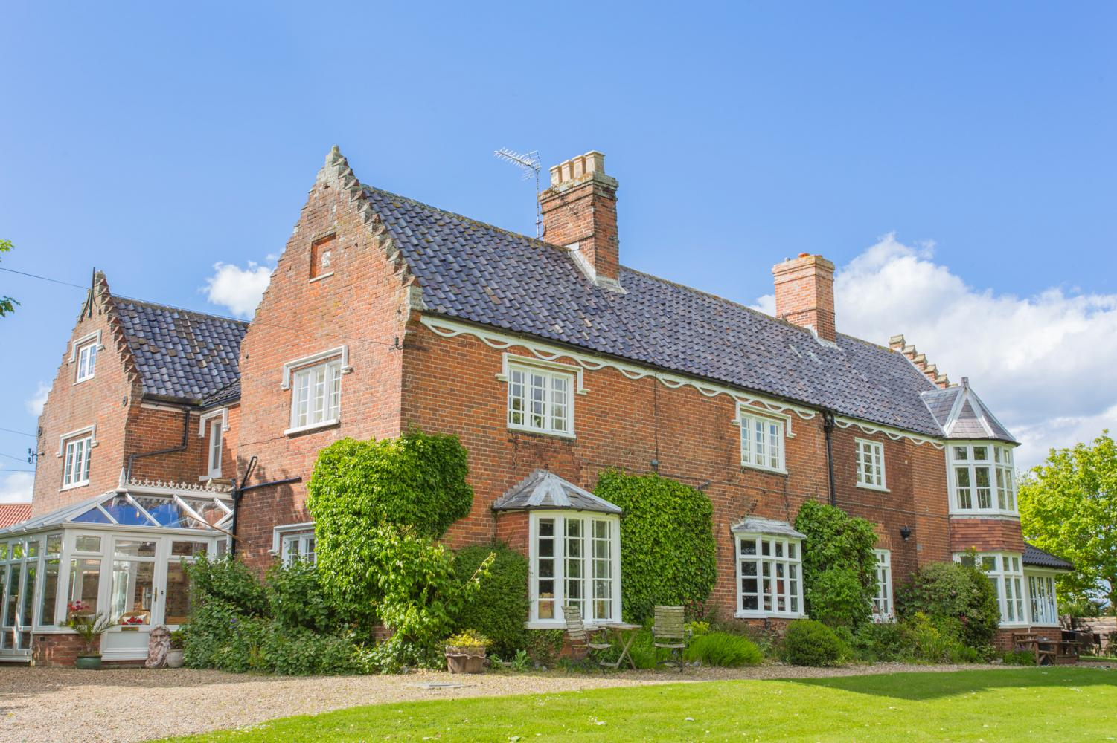

BOOK MEADOW HOUSE
complete and return with payment within 48 hours

Full name of host
Numbers attending
Type of visit (Hen, family, group)
Arrival date
Departure date
Email
Tel number
Mobile
Full address
Postcode
Price quoted
Pay deposit of 50%
Confirm latest T&C read click here
Signature |  | Date

Prices on our website www.norfolkbeachhouse.co.uk

LINEN & TOWLES

Linen is included: bed sheets, duvets slips and pillow cases and a bathroom towel. We do not supply beach towels. Charges will be applied for towels ruined by fake tan.

GAS & ELECTRIC

All gas and electric is included in your rate, but we do monitor excessive use.

DEPOSIT
- A non-refundable deposit of 50% is due on receipt of booking, if your booking is 12 months away then 25% deposit is required
- A balance is due in in full 60 days before arrival
- All payments are non-refundable - see cancellations
- No booking is confirmed until a booking form is received
- Details of BACS are in your booking email
​
CANCELLATIONS, TERMS & REFUNDS
​
​
- The initial and subsequent payment are non-refundable
- If a cancellation request takes place after monies paid and we can re-let the property, we will refund in full less £500 admiration charges
- Where a client wishes to change a date and we can accommodate the change we charge £150 administration costs
- Cancellation due to extenuating circumstances are listed here
​
Should the owners of Norfolk Beach House have to cancel the holiday, every effort will be made to find suitable alternative accommodation. If this is not possible a refund will be made of all monies paid by the hirer to the owners of Norfolk BeachHouse for the accommodation. No further financial claims against the owners will be considered.

SECUIRTY DEPOSIT

A security deposit £250.00 (£500 for Hen Parties or groups) required on all rentals paid with the balance. Refunded in full after your visit.

PRE CONTACT

Tel: 01793 772999 Mob 07545 501763 E: simon@planetpursuits.com
Welcome instructions and key arrangements follow once balance payments are received.

ON ARRVIAL

Make contact with Paul (House manager) 07930331972 to confirm arrival time
SHOPPING DROP
You can arrange a shopping order to be left in the inner hall (behind the house) before arrival, please call to organise Paul (House manager) 07930331972
HOT TUB TERMS

We have very strict terms on the hot tub and its use and cleanliness, your deposit will be at risk.

- Hot tub - no permitted use after 10pm and 8am for any purpose on any date.
- Please respect our neighbours at all times with noise
- No more than 5 people and children under 12 must be supervised
- Hot tub cover must be replaced immediately after use
- We do not provide Beach Towels and house towels are not to be used on the beach

ARRIVAL AND DEPARTURE

Unless previously agreed

Full week Fri 16.00 until Fri 10.00

Weekend Friday 3pm until noon Sun or 10am Mon as agreed for 3 days

Please ensure you have departed at the agreed times to facilitate cleaning!

Liability: It is important to understand you are renting the property under private agreement and therefore we cannot accept any liability for any damage, injury, theft or loss incurred during your stay at the property. If you are concerned about the liability or any loss during your stay you must make provision for your own cover.

Property Protection: As a paying guest we also ask for you to take these minimum precautions, whilst engaged in a short-term rental for the protection of the property and your own health and safety.

- When the property is vacant for any period, all doors and windows to be closed shut and locked where appropriate.

- All electrical appliances to be switched off on departure, except for fridge’s, heating and the boiler.

- Small children to be supervised in the Kitchen and Bathrooms, also please be aware there are many valuable antiques and paintings.

- On arrival please ensure you familiarize yourself with the welcome notes, safety equipment and minimum conditions on departure.

- Children are supervised in and around the Hot tub area and you accept liability for maintaining the Hot tub and the provision of safety for your guests. No use after 10pm and noise restrictions in force at all times

TERMS AND CONDITIONS OF HIRE
Updated Terms are here and supersede all others here
Legal Jurisdiction
This agreement (and any disputes, claims or proceedings of whatsoever nature arising) shall be governed by and shall be construed in accordance with the laws of England. The hirer hereby consents to the exclusive jurisdiction of the English courts in all disputes.
1. Weekly hire
All weekly bookings start from 4.00pm on Friday/Saturday (or the day agreed) and the property must be vacated by 10.00am on the Friday/Saturday (or the day agreed) that the period ends. However if we have no bookings either side of the weekly booking we aim to be flexible on arrival and departure times.
2. Short Breaks Hire
Short break bookings start from 3.00pm on the agreed start day (Friday) and the property must be vacated by noon Sunday or 10am Mon as paid and agreed. However, if we have no bookings either side of the short break we aim to be flexible on arrival and departure times.
3. Deposit
- A non-refundable deposit of 50% is due on receipt of booking, if your booking is 12 months away then £500 deposit is required
- A balance is due in in full 60 days before arrival
- All payments are non-refundable - see cancellations
- No booking is confirmed until a booking form is received
​
Cancellations and Refunds
​
- The initial and subsequent payment are non-refundable
- If a cancellation request takes place after monies paid and we can re-let the property, we will refund in full less £500 admiration charges
- Where a client wishes to change a date and we can accommodate the change we charge £150 administration costs
- Cancellation due to extenuating circumstances are listed here
Should the owners of Meadow House have to cancel the holiday, every effort will be made to find suitable alternative accommodation. If this is not possible a refund will be made of all monies paid by the hirer to the owners of Meadow House for the accommodation. No further financial claims against the owners will be considered.
5. Holiday Insurance
Once booked, the hirer is liable for the complete cottage rental costs. As such it is strongly recommended that the hirer take out suitable holiday insurance to cover costs incurred by unexpected holiday cancellation.
6. Availability
The booking is made on the understanding that the House will be placed at the hirer’s disposal on the dates agreed. Should this not be possible through fire, theft or circumstances beyond the owner’s control, the full amount paid by the hirer will be refunded. However, note that no alternative accommodation can be provided nor will the hirer have any claim against the owner for compensation, loss or expenses. The accommodation is booked strictly on the basis that it is used for holiday accommodation only and there is no right to remain on the property after the expiration of the rental period.
7. Breakages
The hirer undertakes to keep the House and all the furniture, fittings and fixtures in the same state of repair and condition as at the commencement of the letting. The owners must be informed of any breakage. Should the damage result in another booking being cancelled the hirer will be held liable for all consequential losses to the owner.
8. Occupation
The hirer shall use the accommodation strictly for private holiday occupation and this agreement shall not confer on the hirer any security of tenure within the terms of the Housing Act 1988 pursuant to which the occupation shall be deemed to be by way of an excluded tenancy. The hirer shall not do or allow to be done anything which may become a nuisance or annoyance to the occupiers of the neighbouring properties. The hirer shall not allow any person or persons to sleep in or otherwise occupy the accommodation except as specified on the Booking Confirmation letter. If this is not observed, the owner reserves the right to refuse admittance or require that the hirer vacate the property. In this eventuality no refund of monies will be due.
9. Repairs
The hirer shall permit the owner to enter the accommodation at any reasonable time of day to inspect the condition of the decorations for the purpose of carrying out repairs that may be required to be done.
10. Safety
The owners take safety very seriously and do everything to ensure the house is safe, however your stay at the House is entirely at your own risk. The owners can take no responsibility whatsoever for any accident, injury or loss, howsoever caused, during your stay. This includes the use of the hot tub, bbq, garden games and activities. If you are concerned about any safety aspect, please immediately call the house manager.
11. Smoking
For safety reasons we ask that guests do not smoke within the house. You may smoke in the garden, please dispose of cigarette butts carefully.
12. Service
If you should encounter any problems during your stay, or if you are dissatisfied with the service you receive, you should refer to the owners immediately. The owners will take all reasonable steps to correct any problems arising. The owners will not consider claims for problems notified to them after the stay has ended.
13. Amenities
The use of the house includes gas, electricity, water, heating, bedlinen, towels, cleaning products, bathroom toiletries, use of TV/DVD, Hi Fi, WiFi, Broadband, hot tub. White towels are to stay in the house, beach towels are not provided for beach use. The hirer is also entitled to use anything left in the house.
The hirer is also entitled to make use of buckets, body boards, wet suits and other beach related paraphernalia.
14. Cleaning
The house, any equipment used and utensils etc must be left as it is found at the end of the hire period. Your £250 deposit (£400 for hens) will be returned to you if the house is left in a satisfactory state. The hirer must take responsibility to make sure all cleaning products are kept out of the way of children.
15. Left items
The hirer will be notified of any of the hirer’s possessions that have been left at the house after it has been vacated. The hirer must meet the cost of any items returned to them, or if they do not wish to have them returned, the owner will dispose of them. The owner accepts no liability for the hirer’s items getting damaged in transit whilst being returned.
16. Security
The hirer is responsible for the security of the house for the duration of the booking period the hirer is expected to take all reasonable care of the house. The house must be fully secured after leaving it. No windows should be left open and all locks must be secure. When finally leaving the house on the day of departure all keys must be left on the kitchen table for the owner.
17. Parking
Norfolk Beach House (Meadow) has parking for four cars outside the house, we do not accept any liability for your cars parked on our property.
18. Complaints procedure
If the hirer is not fully satisfied with the accommodation offered they must immediately contact the owner and every effort will be made to resolve the problem. If the situation cannot be resolved to the satisfaction of both parties, the owner will attend as soon as possible to inspect the property. The owner will not consider claims for problems notified to them after the hire period has ended.
19. Variation to descriptions and Terms and Conditions
Every care has been taken to ensure the accuracy of the details on the owner’s literature, website and advertising. However changes may be necessary from time to time and the owners reserve the right to make changes without notice. These may included changes to our terms and conditions which will be updated on our website.
20. Hot Tub
The hot tub is used entirely at your own risk. The hirer is responsible for guest’s safety, the use, condition and compliance of rules as stated in the terms and condition of rental and additional notes provided on completing payment. The hot tub and its associated cover is presented in a clean and sanitary state at the start of the rental. If the hirer is not fully satisfied with the hot tub condition they must immediately contact the owner and every effort will be made to resolve the problem. The hirer must ensure the shower is used for the hot tub before use, the hot tub is kept clean, no fake tan and no drinks are consumed in the hot tub.

